Automation squared

Automation facilitates optimising processes and gaining space: An automated guided vehicle system from Melkus Mechatronic has enabled automation system manufacturer SIGMATEK to raise the productivity of its electronics production to a new level. The increase in the level of automation relieves the staff of unproductive ancillary activities. The space gained creates additional room for the installation of another SMT production line. All this contributes to strengthening competitiveness and securing the location.

Göming/Salzburg, 01.09.2025 - Sigmatek GmbH & Co KG (SIGMATEK) is an established manufacturer of solutions for industrial automation. The full-service provider of sequence, motion and safety controllers, as well as drives and visualisation systems, develops and produces the modular electronic components entirely at the company headquarters in Lamprechtshausen near Salzburg.

For a long time, automation the intralogistics was not considered feasible. Production employees had to take care of the supply of materials to workstations and machines and the onward transport of the processed materials themselves. The fact that they had to interrupt their actual work and spend valuable time on unproductive ancillary activities is a huge restriction on productivity.

Intralogistics automation spanning two floors
In two stages, the Austrian manufacturer Melkus Mechatronic GmbH created a driverless transportation system with autonomous transport vehicles (AGV). The first step involved transporting fully assembled control system modules from the assembly cells to the finished goods warehouse or, if required, to a quality assurance workstation. To do this, the compact, manoeuvrable Melkus Q40 vehicles travel up to 100 metres to nine stations and also change floors using a lift.

Especially for electronics production
In the second, significantly greater automation step, the SMT lines are loaded and unloaded with PCB magazines and Euro boxes using AGVs. In close cooperation with SIGMATEK, Melkus Mechatronic developed the Melkus BLS 4060 Rack Stacker for the transport and handling of all standard PCB magazines and classic Euro boxes up to 400 x 600 mm in just six months on the basis of its modular AGV product range.

For automated load transfer, the Melkus Rack Stacker has an innovative lift system that can transfer transported goods to heights of 320 to 1,800 mm. Nevertheless, the AGV fits through 1,950 mm high standard doors. Transfer can take place on either side via an integrated conveyor belt system with clamping jaws for gripping the load carriers. Due to their extremely small footprint, the ESD-compliant vehicles can navigate in the tightest of spaces. The AGVs drive using SLAM navigation under the control of the smart SIGMATEK TCS traffic control system. This is connected to the ERP software and warehouse management system and can translate the data from materials management into transport orders.

An increase in productivity
SIGMATEK employees were involved right from the start. They consider the Melkus rack stackers, which they call Sisi & Franz, an enriching, reliable and relieving addition to their team. Safety in the shared aisles is high, as the AGVs stop reliably in the event of encounters and can be pushed away without effort after an emergency stop, so that the aisle travelled does not lose its function as an escape route for pedestrians.

Although the project has not yet reached its final stage, a significant increase in productivity is already evident. “The Melkus rack stackers Sisi and Franz relieve our employees of unloved secondary tasks and, by eliminating the previous intermediate storage area, create the opportunity to install another SMT line,” explains Gerald Haas, Vice President Operations at SIGMATEK.

Image Captions

Task-specific, ESD-compliant autonomous Melkus BLS4060 Rack Stacker transport vehicles (AGVs) supply automation system manufacturer Sigmatek’s automatic production lines for electronic assemblies at, relieving their human colleagues who gave them the names “Sisi” and “Franz”.  All images, unless otherwise stated: SIGMATEK | 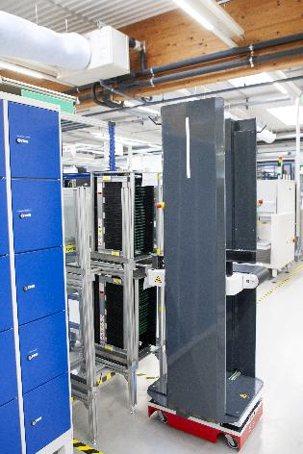
Within the same installation of the open AGV fleet management system TCS (Traffic Control System) from SIGMATEK, Sisi and Franz and the autonomous Melkus Q40 Euro box transporters, which have already been in use for some time, navigate in confined spaces together with people using SLAM navigation. They also use a lift to change floors on their transport routes. | 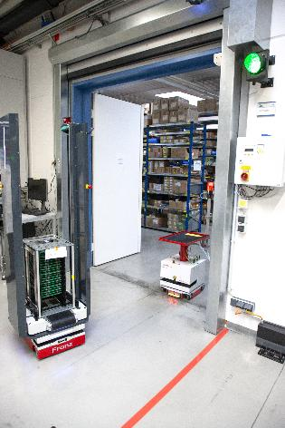
Gerald Haas, Vice President Operations at Sigmatek GmbH & Co KG:  “Sisi and Franz, the Melkus rack stackers, relieve our employees of unloved secondary tasks and eliminated the previous intermediate storage area, making it possible to install another SMT line.” | 

About Melkus Mechatronic
Melkus Mechatronic GmbH is an innovative technology company based in Salzburg. With more than ten years of experience in the field of AGVs and mobile robotics, it provides customers with highly available AGVs for flexible in-house transport with maximum reliability. Swiftly installed and commissioned, these enable Melkus operators to organise their intralogistics more efficiently and to establish resource-saving processes. Melkus employs highly qualified and committed staff and offers a range of six AGVs for a wide variety of applications. www.melkus-mechatronic.com

